Name = Sasmitha W.A.M.

ID Number = IT24101669

Lab 06

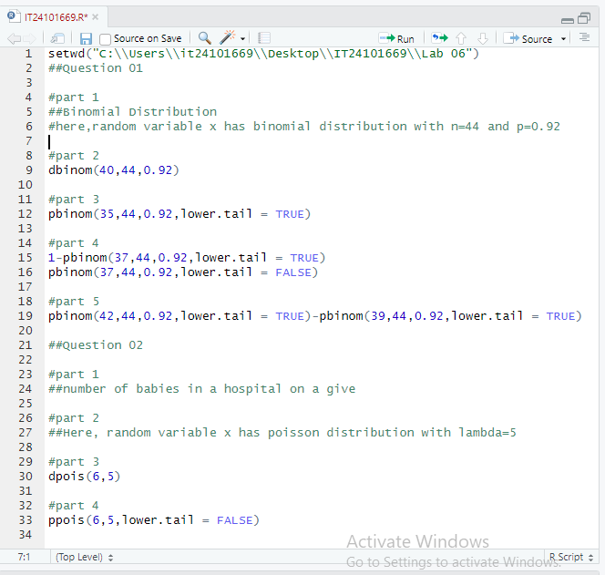

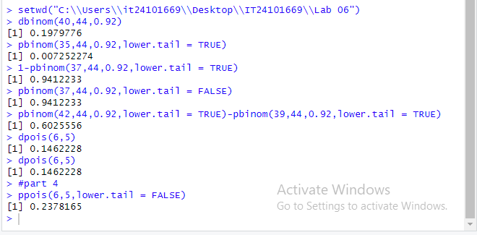

**Exercise**

